**Unearthing the environmental impact of human activity: A global CO2 emission analysis**

1. Introduction

# 1.1 OVERVIEW

Carbon dioxide emissions or CO2 emissions are emissions stemming from the burning of fossil fuels and the manufacture of cement; they include carbon dioxide produced during consumption of solid, liquid, and gas fuels as well as gas flaring.Global energy-related CO2 emissions grew by 0.9% or 321 Mt in 2022, reaching a new high of over 36.8 Gt. Following two years of exceptional oscillations in energy use and emissions, caused in part by the Covid-19 pandemic, last year’s growth was much slower than 2021’s rebound of more than 6%. Emissions from energy combustion increased by 423 Mt, while emissions from industrial processes decreased by 102 Mt.In a year marked by energy price shocks, rising inflation, and disruptions to traditional fuel trade flows, global growth in emissions was lower than feared, despite gas-to-coal switching in many countries. Increased deployment of clean energy technologies such as renewables, electric vehicles, and heat pumps helped prevent an additional 550 Mt in CO2 emissions. Industrial production curtailment, particularly in China and Europe, also averted additional emissions.Specific challenges in 2022 contributed to the growth in emissions. Of the 321 Mt CO2 increase, 60 Mt CO2 can be attributed to cooling and heating demand in extreme weather and another 55 Mt CO2 to nuclear power plants being offline.CO2 growth in 2022 was well below global GDP growth of 3.2%, reverting to a decade-long trend of decoupling emissions and economic growth that was broken by 2021’s sharp rebound in emissions. Improvements in the CO2 intensity of energy use were slightly slower than the past decade’s average.

# 1.2 Purpose

The purpose of the project is to reduce the emission of Co2 wordwide. Here we analyze the C02 emission in various countries world wide and also in India. Also we have to analyze the factors involving the emission of Co2. From the Analysis we can find the remedies to control the Co2 emissions in world wide.

2.Problem Definition & Design Thinking

# 2.1 Empathy Map

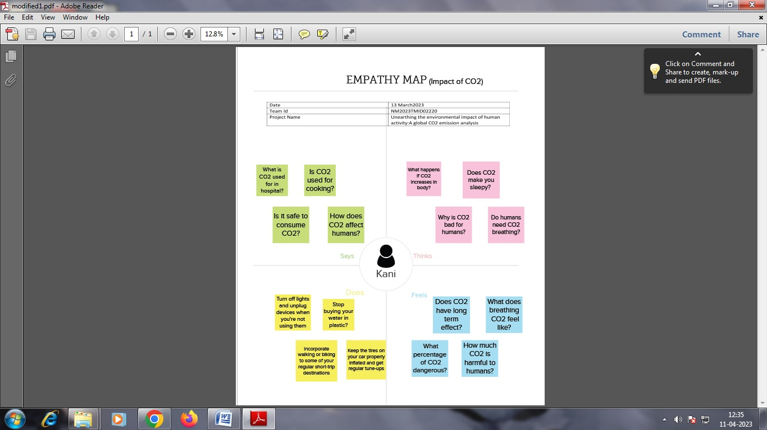

# 2.2 Ideation & Brainstorming Map

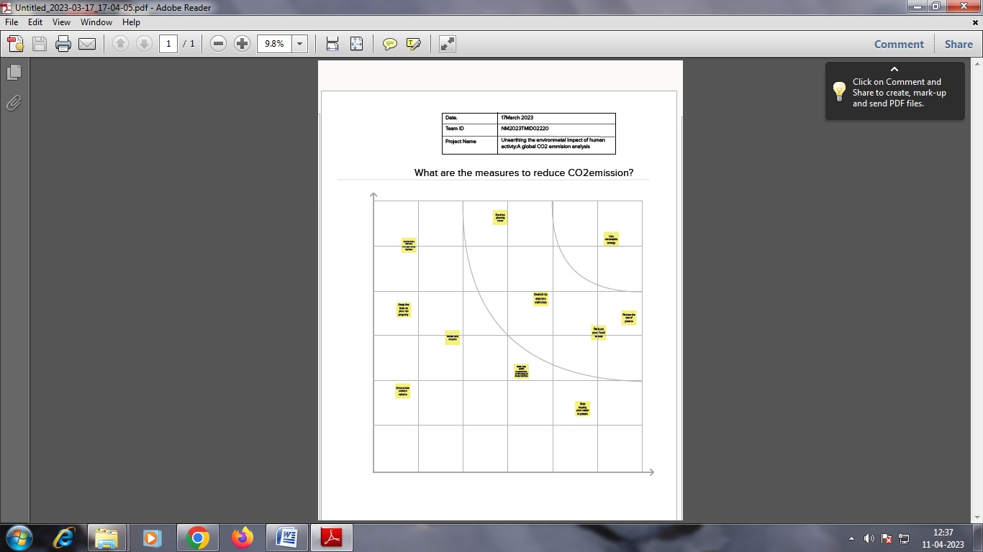

3.Result

Dashboard 1

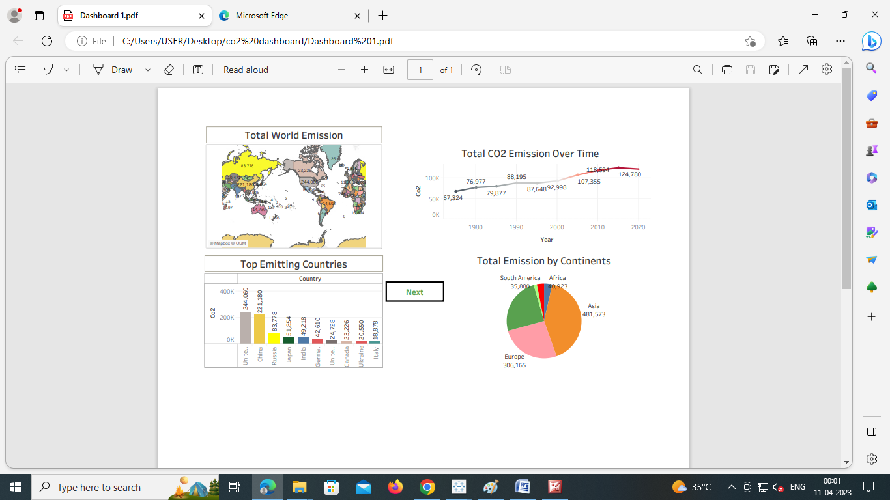

Dashboard 2

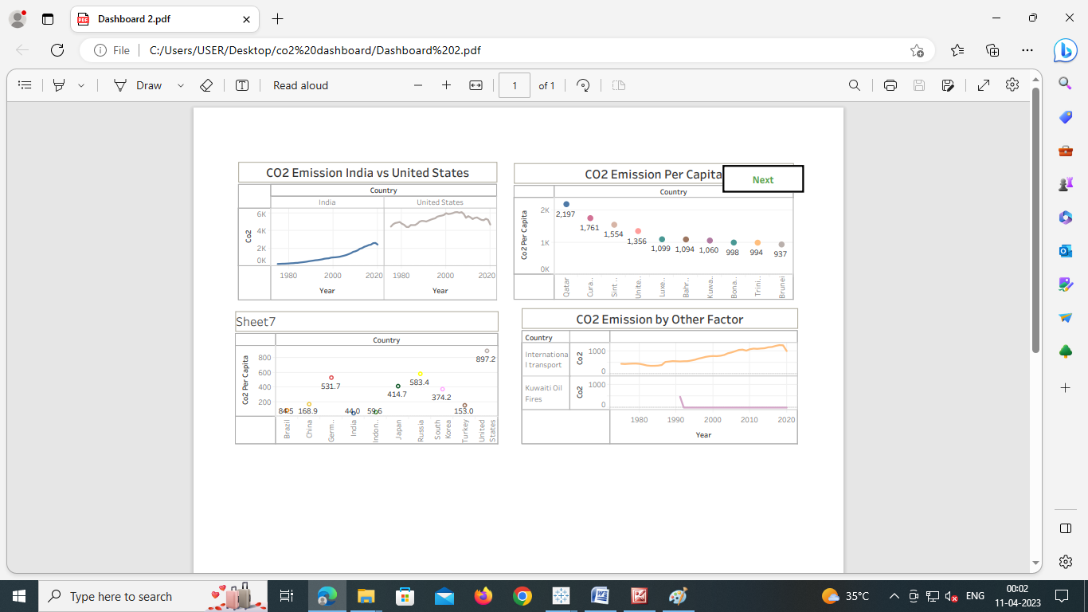

Dashboard 3

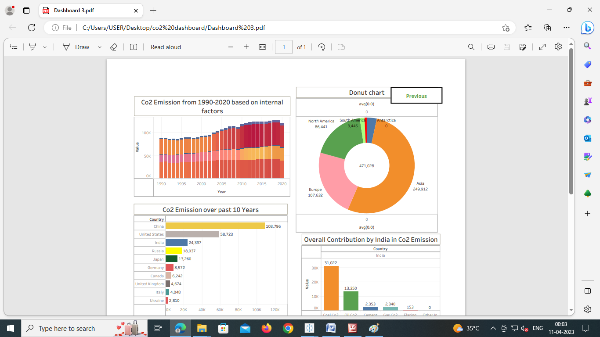

Dashboard 4

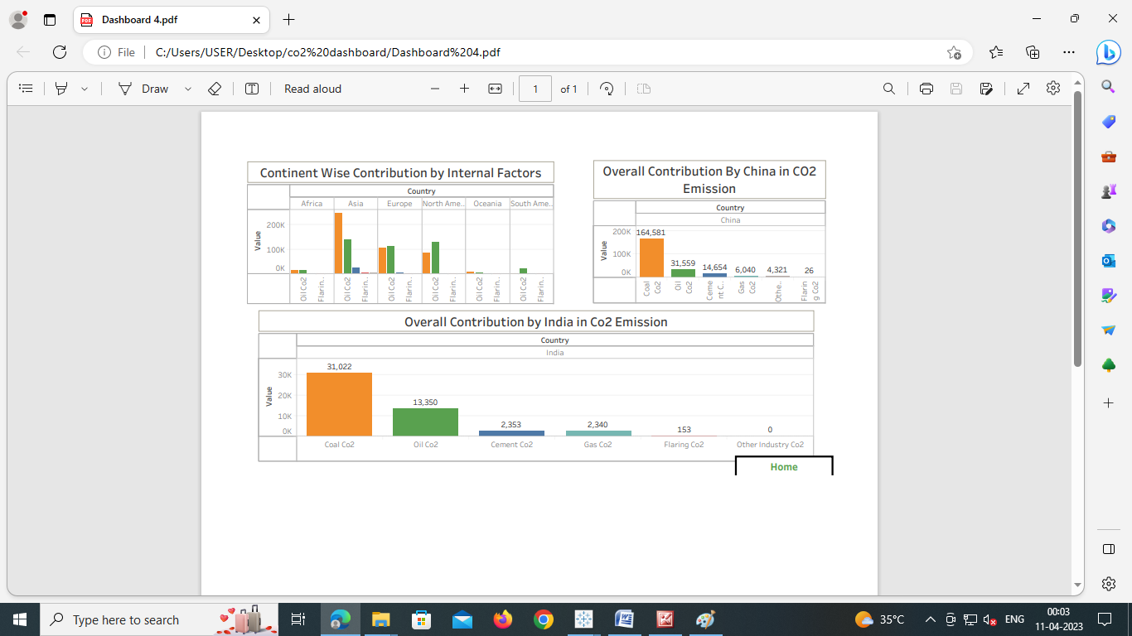

# 4.Advantages & Disadvantages

Advantages

* Future CO2 increases will boost agriculturalproductivity and improve droughtresistance, thereby bolstering food security and contributing to a greener, lusher plane
* carbon dioxide, which is a greenhouse gas that traps heat close to Earth. It helps Earthhold some of the heat it receives from the Sun so it doesn't all escape back into space.

Disadvantages

* co2 is one of the toxic gas.
* co2 increase the earth temperature and so global warming.
* increase in percentage of co2 in air causes melting of snow and hence their are increase in sea water level.

**Applications**

The development of economies and energy usage can significantly impact the carbon dioxide (CO2) emissions in the Middle East and North Africa (MENA) countries. Therefore, this study aims to analyze the factors that determine CO2 emissions in MENA under the environmental Kuznets curve (EKC) framework by applying novel quartile techniques on data for CO2 emissions, real income, renewable and non-renewable energy consumption, and urbanization over the period from 1990 to 2015. The results from the estimations suggest that renewable energy consumption significantly reduces the level of emissions; furthermore, its impact increases with higher quartiles. In addition, non-renewable energy consumption increases CO2 emissions, while its magnitude decreases with higher quartiles. The empirical results also confirm the validity of EKC hypothesis for the panel of MENA economies. Policymakers in the region should implement policies and regulations to promote the adoption and use of renewable energy to mitigate carbon emissions.

**6.Conclusion**

**Here we conclude the following steps will reduce the co2 emissions. We have to stop buying your water in plastic. Incorporate walking or biking to some of your regular short-trip destinations**.**Turn off lights and unplug devices when you’re not using them.Keep the tires on your car properly inflated and get regular tune-ups.** **Use alternative transportation (bus, train, carpool, or bike) to get to work one day per week**

7.Future Scope

With carbon-intensive growth reminiscent of 2010, the global economic recovery from the Covid-19 crisis has not been [the sustainable recovery that IEA Executive Director Fatih Birol called for at the onset of the pandemic](https://www.iea.org/commentaries/put-clean-energy-at-the-heart-of-stimulus-plans-to-counter-the-coronavirus-crisis) in 2020. Nonetheless, certain advanced economies have emphasised decarbonisation measures in their economic recovery. The IEA’s [Sustainable Recovery Tracker](https://www.iea.org/reports/sustainable-recovery-tracker/tracking-sustainable-recoveries) has shown that as of October 2021, USD 470 bilion had been earmarked for sustainable measures within recovery packages through 2030. Looking at the crucial 2021-2023 period, measures to date could mobilise around USD 400 billion a year in clean energy and sustainable recovery investment. However, this would still only represent 40% of the investment needed in the IEA’s [Sustainable Recovery Plan](https://www.iea.org/reports/sustainable-recovery), which is aligned with a pathway towards reaching net zero emissions by 2050 globally.

8.Appendix

|  |  |
| --- | --- |
|  | Dashbooard 1  <div class='tableauPlaceholder' id='viz1681375729739' style='position: relative'><noscript><a href='#'><img alt='Dashboard 1 ' src='https:&#47;&#47;public.tableau.com&#47;static&#47;images&#47;Da&#47;Dashboard1_16811979880250&#47;Dashboard1&#47;1_rss.png' style='border: none' /></a></noscript><object class='tableauViz' style='display:none;'><param name='host_url' value='https%3A%2F%2Fpublic.tableau.com%2F' /> <param name='embed_code_version' value='3' /> <param name='site_root' value='' /><param name='name' value='Dashboard1_16811979880250&#47;Dashboard1' /><param name='tabs' value='no' /><param name='toolbar' value='yes' /><param name='static_image' value='https:&#47;&#47;public.tableau.com&#47;static&#47;images&#47;Da&#47;Dashboard1_16811979880250&#47;Dashboard1&#47;1.png' /> <param name='animate_transition' value='yes' /><param name='display_static_image' value='yes' /><param name='display_spinner' value='yes' /><param name='display_overlay' value='yes' /><param name='display_count' value='yes' /><param name='language' value='en-US' /></object></div> <script type='text/javascript'> var divElement = document.getElementById('viz1681375729739'); var vizElement = divElement.getElementsByTagName('object')[0]; if ( divElement.offsetWidth > 800 ) { vizElement.style.width='100%';vizElement.style.height=(divElement.offsetWidth*0.75)+'px';} else if ( divElement.offsetWidth > 500 ) { vizElement.style.width='100%';vizElement.style.height=(divElement.offsetWidth*0.75)+'px';} else { vizElement.style.width='100%';vizElement.style.height='1327px';} var scriptElement = document.createElement('script'); scriptElement.src = 'https://public.tableau.com/javascripts/api/viz_v1.js'; vizElement.parentNode.insertBefore(scriptElement, vizElement); </script> |

Dashboard 2

<div class='tableauPlaceholder' id='viz1681461482729' style='position: relative'><noscript><a href='#'><img alt='Dashboard 2 ' src='https:&#47;&#47;public.tableau.com&#47;static&#47;images&#47;Da&#47;Dashboard2_16811982785670&#47;Dashboard2&#47;1_rss.png' style='border: none' /></a></noscript><object class='tableauViz' style='display:none;'><param name='host_url' value='https%3A%2F%2Fpublic.tableau.com%2F' /> <param name='embed_code_version' value='3' /> <param name='site_root' value='' /><param name='name' value='Dashboard2_16811982785670&#47;Dashboard2' /><param name='tabs' value='no' /><param name='toolbar' value='yes' /><param name='static_image' value='https:&#47;&#47;public.tableau.com&#47;static&#47;images&#47;Da&#47;Dashboard2_16811982785670&#47;Dashboard2&#47;1.png' /> <param name='animate_transition' value='yes' /><param name='display_static_image' value='yes' /><param name='display_spinner' value='yes' /><param name='display_overlay' value='yes' /><param name='display_count' value='yes' /><param name='language' value='en-US' /></object></div> <script type='text/javascript'> var divElement = document.getElementById('viz1681461482729'); var vizElement = divElement.getElementsByTagName('object')[0]; if ( divElement.offsetWidth > 800 ) { vizElement.style.width='100%';vizElement.style.height=(divElement.offsetWidth*0.75)+'px';} else if ( divElement.offsetWidth > 500 ) { vizElement.style.width='100%';vizElement.style.height=(divElement.offsetWidth*0.75)+'px';} else { vizElement.style.width='100%';vizElement.style.height='1327px';} var scriptElement = document.createElement('script'); scriptElement.src = 'https://public.tableau.com/javascripts/api/viz_v1.js'; vizElement.parentNode.insertBefore(scriptElement, vizElement); </script>

Dashboard 3

|  |  |
| --- | --- |
|  | <div class='tableauPlaceholder' id='viz1681461968329' style='position: relative'><noscript><a href='#'><img alt='Dashboard 3 ' src='https:&#47;&#47;public.tableau.com&#47;static&#47;images&#47;Da&#47;Dashboard3_16812018709020&#47;Dashboard3&#47;1_rss.png' style='border: none' /></a></noscript><object class='tableauViz' style='display:none;'><param name='host_url' value='https%3A%2F%2Fpublic.tableau.com%2F' /> <param name='embed_code_version' value='3' /> <param name='site_root' value='' /><param name='name' value='Dashboard3_16812018709020&#47;Dashboard3' /><param name='tabs' value='no' /><param name='toolbar' value='yes' /><param name='static_image' value='https:&#47;&#47;public.tableau.com&#47;static&#47;images&#47;Da&#47;Dashboard3_16812018709020&#47;Dashboard3&#47;1.png' /> <param name='animate_transition' value='yes' /><param name='display_static_image' value='yes' /><param name='display_spinner' value='yes' /><param name='display_overlay' value='yes' /><param name='display_count' value='yes' /><param name='language' value='en-US' /></object></div> <script type='text/javascript'> var divElement = document.getElementById('viz1681461968329'); var vizElement = divElement.getElementsByTagName('object')[0]; if ( divElement.offsetWidth > 800 ) { vizElement.style.width='1000px';vizElement.style.height='827px';} else if ( divElement.offsetWidth > 500 ) { vizElement.style.width='1000px';vizElement.style.height='827px';} else { vizElement.style.width='100%';vizElement.style.height='1277px';} var scriptElement = document.createElement('script'); scriptElement.src = 'https://public.tableau.com/javascripts/api/viz_v1.js'; vizElement.parentNode.insertBefore(scriptElement, vizElement); </script> |
|  |  |
|  |  |
|  |  |
|  | </div> |
|  | </section> |

Dashboard 4

div class='tableauPlaceholder' id='viz1681462129984' style='position: relative'><noscript><a href='#'><img alt='Dashboard 4 ' src='https:&#47;&#47;public.tableau.com&#47;static&#47;images&#47;Da&#47;Dashboard4_16807716492280&#47;Dashboard4&#47;1_rss.png' style='border: none' /></a></noscript><object class='tableauViz' style='display:none;'><param name='host_url' value='https%3A%2F%2Fpublic.tableau.com%2F' /> <param name='embed_code_version' value='3' /> <param name='site_root' value='' /><param name='name' value='Dashboard4_16807716492280&#47;Dashboard4' /><param name='tabs' value='no' /><param name='toolbar' value='yes' /><param name='static_image' value='https:&#47;&#47;public.tableau.com&#47;static&#47;images&#47;Da&#47;Dashboard4_16807716492280&#47;Dashboard4&#47;1.png' /> <param name='animate_transition' value='yes' /><param name='display_static_image' value='yes' /><param name='display_spinner' value='yes' /><param name='display_overlay' value='yes' /><param name='display_count' value='yes' /><param name='language' value='en-US' /></object></div> <script type='text/javascript'> var divElement = document.getElementById('viz1681462129984'); var vizElement = divElement.getElementsByTagName('object')[0]; if ( divElement.offsetWidth > 800 ) { vizElement.style.width='100%';vizElement.style.height=(divElement.offsetWidth*0.75)+'px';} else if ( divElement.offsetWidth > 500 ) { vizElement.style.width='100%';vizElement.style.height=(divElement.offsetWidth*0.75)+'px';} else { vizElement.style.width='100%';vizElement.style.height='977px';} var scriptElement = document.createElement('script'); scriptElement.src = 'https://public.tableau.com/javascripts/api/viz_v1.js'; vizElement.parentNode.insertBefore(scriptElement, vizElement); </script>

**story**

<div class='tableauPlaceholder' id='viz1681462364834' style='position: relative'><noscript><a href='#'><img alt='Story 1 ' src='https:&#47;&#47;public.tableau.com&#47;static&#47;images&#47;St&#47;Story1_16812025753570&#47;Story1&#47;1_rss.png' style='border: none' /></a></noscript><object class='tableauViz' style='display:none;'><param name='host_url' value='https%3A%2F%2Fpublic.tableau.com%2F' /> <param name='embed_code_version' value='3' /> <param name='site_root' value='' /><param name='name' value='Story1_16812025753570&#47;Story1' /><param name='tabs' value='no' /><param name='toolbar' value='yes' /><param name='static_image' value='https:&#47;&#47;public.tableau.com&#47;static&#47;images&#47;St&#47;Story1_16812025753570&#47;Story1&#47;1.png' /> <param name='animate_transition' value='yes' /><param name='display_static_image' value='yes' /><param name='display_spinner' value='yes' /><param name='display_overlay' value='yes' /><param name='display_count' value='yes' /><param name='language' value='en-US' /></object></div> <script type='text/javascript'> var divElement = document.getElementById('viz1681462364834'); var vizElement = divElement.getElementsByTagName('object')[0]; vizElement.style.width='1016px';vizElement.style.height='991px'; var scriptElement = document.createElement('script'); scriptElement.src = 'https://public.tableau.com/javascripts/api/viz_v1.js'; vizElement.parentNode.insertBefore(scriptElement, vizElement); </script>